Loading:

A load means **the quantity of work, and allocating the quantity of work to the processes necessary to manufacture each item** is called loading.

No.of available working hours :15.5 x 18 x 7=1953hrs

All the production process should be less than the available production time

Finite loading:Finite loading is an approach which only allocates work to a work center ( up to a set limit here being it for 4 months time. This limit is the estimate of capacity for the work center (based on the times available for loading). Below shows the loading of 4 different production lines . The first production line shows the combined production for the lines 1,5 and 6 from the product portfolio. The second picture shows for line 2 and 4 followed by the 3rd loading image that describes the 3 lines alone. The 4th production line shows the production process for new parts.

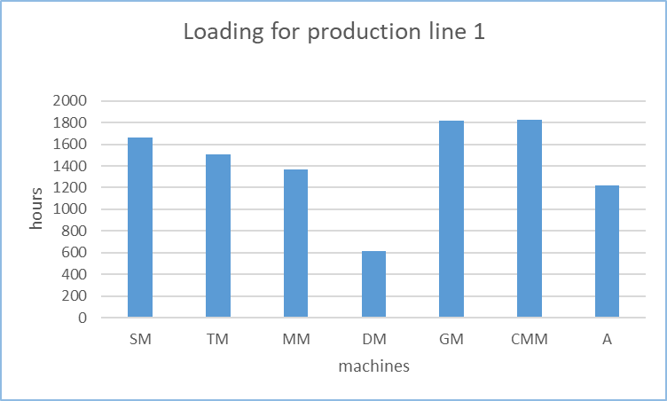

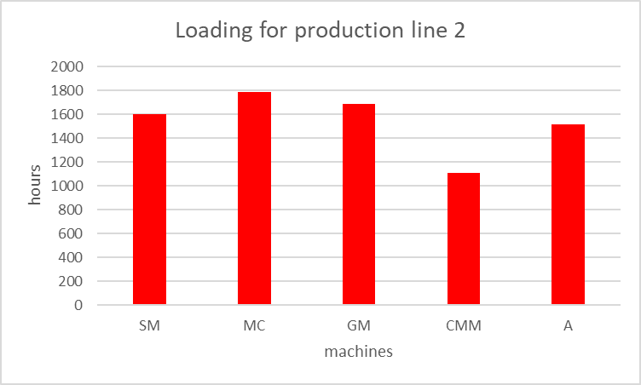

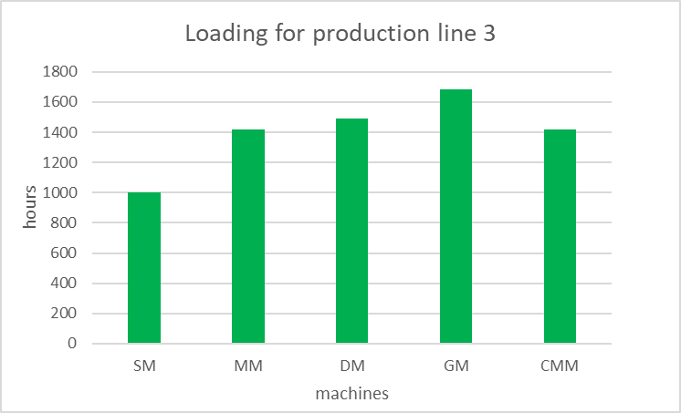

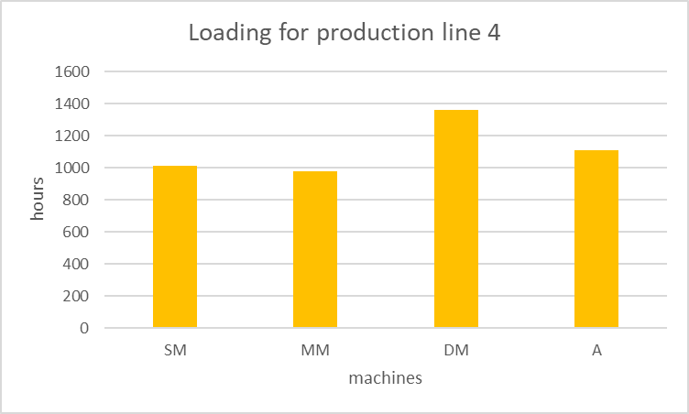

Monitoring and control

This is the process followed by push demand

